# **ENGR 1181 | Lab 7: Wind Turbine**

*-* Formal Lab Report

*-* Team N

Accountability Acknowledgement:

I declare and acknowledge that I have offered a significant contribution to this team writing assignment and that the work I have submitted to the group is my own.

|  |  |  |  |
| --- | --- | --- | --- |
| Name (typed) | Role | Signature | Date |
| Justin Lewis |  | Justin Lewis | 10/26/23 |
| Nick Schwalm |  | Nicholas Schwalm | 10/26/23 |
| Joey Silvaggio |  | Joseph Silvaggio | 10/26/23 |
|  |  |  |  |
|  |  |  |  |

From: Group Letter – Nick Schwalm, Joey Silvaggio, Justin Lewis Wind Turbine Lab Report

To: Supervisor 11/03/23

**Executive Summary**

**Background and Purpose**

The Wind Turbine Lab familiarizes students with some different concepts including: explain fluid mechanics and Bernoulli’s equation, associate wind velocity with the pressure changes in fluids, observe the conversion of wind energy to electrical energy, explore the characteristics of the wind tunnel and turbine, determine the influence of wind turbine blade design on the generated power, investigate optimum number of blades and possible blade orientations ,and measure the influence of the pitch angle in a Wind turbine design on power generated. The purpose of this lab is to find the effects of blade characteristics (size, shape, and number) on the overall power generated by the wind turbine. ~[1]

**Results & Analysis:**

Based off the data collected and the plots created from this data, our team was able to identify several trends. The initial trends stemming from Figure 1, where we tested the power output of the wind turbines with three different blade counts, configured at two separate angles. The first one being the red hub pitch with an angle of 30° and the second one being the blue hub pitch with an angle of 45°. From Figure 1, the power output for the red hub pitch is roughly double that of the blue hub pitch. Investigating further, the power output for the blue hub pitch increases as the number of blades increases but for the red hub pitch the power output slightly decreases as the number of blades increase. Further trends can be found in Figure 2, which investigated the power output at different blade counts dependent on the wind speeds. This revealed that as blade count increases, the power output also decreases. The configuration of the red hub pitch and 6 blades had the most efficient power output when compared to 2 and 3 blade configurations at the same wind speeds. ~[1]

**Conclusions and Recommendations:**

Following the theory that as wind velocity increases, the power output on the wind turbine should increase as well as seen in Figure 1. Through our experimentation, our group tested different shapes, sizes, and total number of blades for a wind turbine. After testing each shape and number of blades, we looked at the data produced by each type of wind turbine blade to optimize the best way to maximize the power output of a wind turbine at multiple different wind velocity.~[1]

**Lab Report**

**Intro:**

**Background & Purpose:**

In the Wind Turbine Lab students get an introduction to concepts that correlate to wind turbines. Those concepts include fluid flow; the relationship between pressure, velocity, and wind energy; and generated power and efficiency of wind turbine used during the design process. Throughout the lab students gain a deeper knowledge of these concepts and begin to find relationships between these concepts. Those relationships include fluid mechanics and Bernoulli’s equation, how wind velocity and pressure affect fluids, the conversion between wind energy and electrical energy, the characteristics of the wind tunnel and wind turbine, the influence that blade design on generated power, how the number of blades effects the generated power, and how pitch angle of the hub effects generated power. ~[1]

The purpose of this lab is to gain knowledge of how different components of the turbine affect the generated power. Also, with the knowledge of the component's students can find ways to make the most efficient wind turbine. ~[1]

**Roadmap:**

The following paper will include an explanation of the procedures our team took throughout the experiment, the trends found within the experiment, and the conclusions that can be made from those trends. Due to issues with our data collection and conversion, our experiment is backed up by the sample data provided. The trends and conclusions will be supported by the graphs from the sample data that are found in the appendix below.~[1]

**Experimental Methodology:**

**Steps:**

At the beginning of the experiment, our group set up a wind tunnel apparatus to test different wind velocities against different blade shapes and counts. The apparatus can be seen in Figure 2A, and 2B respectively. Before conducting any test, our group had to verify electrical and fluid connections by checking that “the power cable was connected from the variable power supply to the wind tunnel wind source fan with the color coding of black to black and red to red at the power supply”. We then proceeded to make sure the variable power supply was plugged in and turned off, and check that the voltage (CV) knob was at zero and the current (CC) knob was at maximum. Finally, each member of the team produced a single blade design they believed would produce the most power output, and so the first trials commenced. The first test consisted of one blade being tested at a time to conclude which blade design would produce the greatest power output. After this step, we tested the best blade design which we labeled “Idaho” on a 3-second interval at different velocities, and different numbers of blades ranging from two, three, and finally six blades. Each number of blades was also tested at varying voltages ranging from 6V to 12V and were placed within a red 30-degree hub pitch. The design we selected as the best is then placed into a blue 45**-**degree hub pitch and tested the same as the 30**-**degree hub pitch mentioned above. Our group recorded each power output of each blade design and number of blades using an “NI MyDAQ” to record and translate data into a MATLAB file, and for extra precaution, we recorded each on an excel spreadsheet in tables to label each power output to its corresponding hub pitch, wind velocity, blade type, and number of blades.~[1]

**Equipment:**

Before starting the experiment, the provided equipment should be arranged as seen in Figure 2B. The equipment on hand should be a Wind tunnel flow tube, wind source fan, flow straightener vanes in the positive orientation, pitot tube, static tube, wind turbine mount, and wind turbine power cable. Along with these, the experiment also includes a variable power supply and power leads, a NI MyDAQ with its attached breakout board. All required materials should be provided as seen in Figure 2A. Any attempts to recreate this experiment should follow this list of equipment to produce similar results, but this experiment is not solely locked down to only these specific items.~[1]

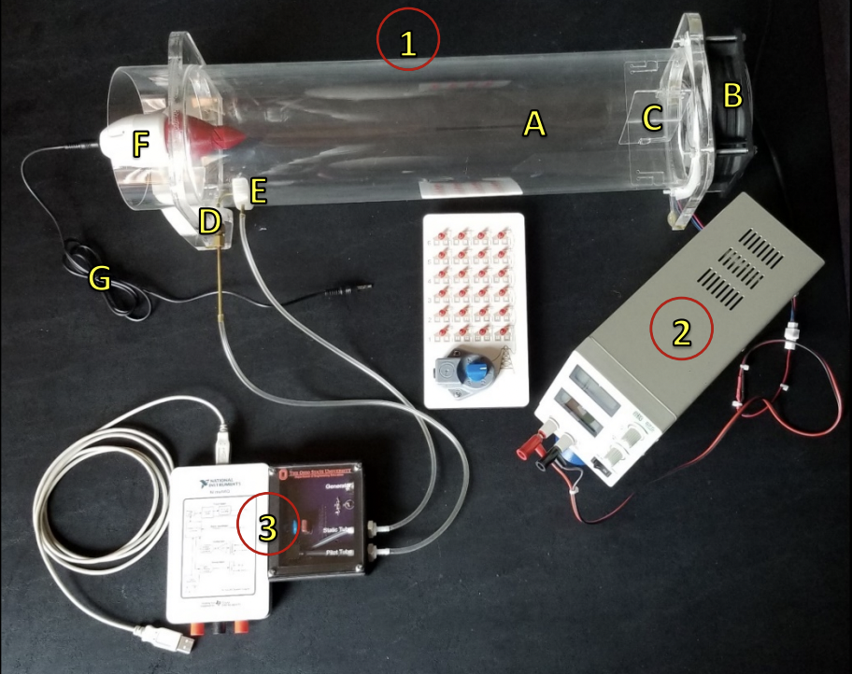

Figure A: Wind Tunnel Apparatus

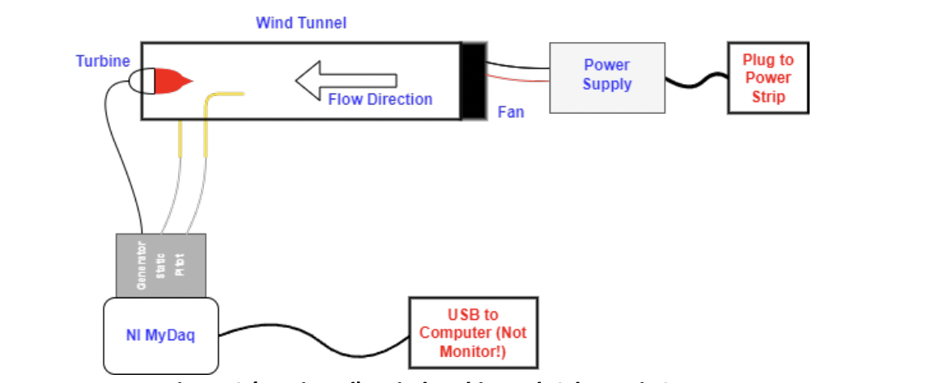

Figure B: 2D Wind Tunnel lab schematic set-up

**Blade Designs:**

Figure C: Teardrop Design Figure D: Knife Design

Figure E: Eyebrow Design Figure F: Idaho Design

**Results:**

**Measurement Observations:**

Our observations were based on the sample data which only provided the number of blades, the power output for each blade count, and the hub pitch used. First, we found that a thicker square design, labeled as “Idaho” produced the best power output compared to our other blade shape designs. We believe this is the case because the wider square blade will be able to resistant the wind more and therefore gets turned faster. We believe the issue with our thinner blades was that they were so small that they would just cut through the wind rather than being turned by the wind. Then, we found the optimal number of blades that produced the most power was 6 blades. When the experiment was run, the 6-blade configuration produced enough power to blow all the blades out of the hub pitch. This matches the graphical results that support that the power output for the 6-blade configuration was greater than those of the 2 and 3-blade configuration. Last, we found that the 30-degree hub pitch was optimal for producing the largest power output compared to the 45-degree hub pitch. ~[2]

**Data Analysis:**

After all the results from the experiment were loaded and run through MATLAB, three figures were created that showed number of blades vs. Power output, wind velocity vs. Power output, and wind speed vs. power output for each number of blades. These graphs helped our group identify trends between the number of blades and power output, and how different wind speeds affected this. After the trends were identified, our group was able to make sense of the data produced by the experiment, leading to our results. Our team decided that 6 blades is the best number of blades for a wind turbine to produce the most power output, because according to the data produced, 6 blades consistently produce the most power, regardless of wind speed. It is also worth noting that using the 30-degree red hub cap also works to produce more power output than using its counterpart, the blue 45-degree hub cap. ~[2]

**Figure 1: Wind Turbine Power Output (W) of different Hub Pitches depending on Number of Blades**

**Figure 2: Wind Turbine Power Output (W) of different Blade Counts vs. Wind Speeds (m/s)**

**Blade Design:**

How we came up with for our final design was we wanted to incorporate a thicker/ wider faced blade because we found that a thinner design was not efficient. Those designs included a tear drop design (Figure C) which had an oval base that funneled into a tip. The second design was a knife design (Figure D) which had a rectangular base that is cut on an angle that forms the knife-like design. The last design was an eyebrow design, the blade had a thin rectangular base and got thinner as you go along the blade (Figure E). Our final design we named Idaho thinking that our design looked like the state of Idaho, after further analysis our team realized that the shape of our blade was the shape of Nevada. The actual design was a thick square shape blade with cuts that form a point on top and a little cut at the bottom, so the blade would fit in the hub pitch (Figure F). We found that a thicker square design was able to catch more of that wind rather than the other thinner designs that just would cut through the air. Figure 3 shows the different power outputs between the different blade shape designs and supports our “Idaho” shape choice.

Figure F: Idaho

**Discussion:**

**Discuss Trends:**

There are several trends that can be identified from analyzing the data. The first trend we can see in Figure 1, is that the red hub pitch (angle of 30°) has a much larger power output when to the blue hub pitch (angle of 45°). This was also an important trend to move forward with testing for the highest power outputs based off number of blades. Further trends can be identified in Figure 2 which compared the power output and blade count of the most efficient blade shape at different wind speeds. From this graph, the power output for the 6-blade configuration is greater than those of the 2 and 3-blade configurations for all points. Figure 2 also shows that the power outputs for the 2 and 3-blade configurations are very similar at the same wind speeds. This supports that a higher blade count contributes to a greater power output. From Figure 2, can be seen that the largest power output for the 2-blade configuration was 5.972 W at a wind speed of 7.597 m/s, and the largest power output for the 3-blade configuration was 6.08 W at a wind speed 7.605 m/s. This proves that the 2 and 3-blade configurations have nearly identical power outputs at approximately the same wind speeds. Figure also reveals the blade count with the most efficient power output. The power output for the 2-blade configuration was 2.608 W at a wind speed of 5.267 m/s. The power output for the 3-blade configuration was 2.568 W at a wind speed of 5.202 m/s. The power output for the 6-blade configuration was 2.625 W at a wind speed of 5.044 m/s. ~[2]

**Comparison to Theory:**

Not all our findings agree with Bernoulli's principle. Despite this, we found that using 6 blades, as wind velocity increased, the power output also increased, and according to the principle, as the velocity of a body of gas increases, its pressure should decrease, resulting in a more efficient wind turbine. Our results proved this, and it can be assumed that because the output power increased, the wind pressure decreased. In theory, our “Idaho” blade should not be as efficient because wind does not move as fast over a flat surface than it does a curved, but the length and overall area of our blade design would be able to capture and use more of the total wind coming through the turbine. This in turn would justify our results, that having 6 blades would produce the most power output because they can cover more area, and if shaped like our blade design “Idaho” potentially maximize the full extent of the wind turbine.~[1]

**Potential Error:**

Although there could have been multiple forms of human and technical error within the experiment such as a weaker material that was easy to break, weak power supply, or a team member not starting the data collection at the right time, as well other unknown forms of human error. Other limitations could consist of duplicating the same blade by cutting it out would not produce an exact replica, and there for each blade has a different drag force which would introduce random error into our experiments results.

**Conclusions and Recommendations:**

**Summary:**

Our team initially tested 4 different blade shapes to determine which blade shape gave the best power output. We determined our Idaho blade design to be the most efficient blade shape. We then used this blade to determine which hub pitch provides the greatest power output. From our data, we found the 30° hub pitch results in the greatest power output. From this information, we were then able to test the number of blades of our optimal blade shape and hub pitch angle at different wind speeds. From these tests we were able to interpret the graphs and identify trends. What we found was that the 6-blade configuration on the 30° hub pitch produced the most efficient power output. ~[2]

**Resolving Error:**

There are several different approaches to resolving errors. The most common approach is to increase the number of trials. This would benefit the validity of this experiment greatly and resolve errors that could have occurred. Such errors could be resolved in this manner being the miscommunication on the start time of data collection and other unknown human errors that could have occurred during the experiment. One other approach that could eliminate the error of inconsistent blade shape is the use of sturdier materials for the blades that can be cut accurately and precisely. This error could also be minimized with the use of more exact tools matched with improved materials. This would increase the precision of each cut and ensure accuracy of wind blade shapes.

**Recommendations:**

Our team concluded that 6 blades on a 30-degree hub pitch produces the most power output. Therefore, we recommend that the wind turbine manufacturing company use our results as a reference to increase the efficiency of their small-scale wind turbines. To maximize efficiency and optimize more power output, our team recommends using 6 blades and 30-degree hub pitch. Based on our results, this configuration will provide the optimal power output for the wind turbine manufacturing company.

**Appendix:**

**Figure 1: Wind Turbine Power Output (W) of different Hub Pitches depending on Number of Blades (Based on Sample Data)**

**Figure 2: Wind Turbine Power Output (W) of different Blade Counts vs. Wind Speeds (m/s) (Based on Sample Data)**

|  |  |  |  |
| --- | --- | --- | --- |
|  |  |  |  |
|  | **Blade Design No.** | **Single Blade Power Output (watts)** | **Blade Shape  Description** |
|  | **1** | 0.0000 | Teardrop |
|  | **2** | 0.0100 | Eyebrow |
|  | **3** | 0.0200 | Knife |
|  | **4** | 0.0600 | Idaho |
|  |  |  |  |

**Figure 3: Data Used to Determine Optimal Blade Shape (From Experiment)**

**Figure 4: Wind Turbine Power Output vs. Wind Velocity with Varied Blade Numbers (From Experiment )**

|  |  |  |  |  |
| --- | --- | --- | --- | --- |
|  | **Angle** | **2-blades** | **3-blades** | **6-blades** |
|  | 30o | 0.2600 | 0.6400 | 0.7900 |
|  | 45o | 0.3000 | 0.4300 | 0.6200 |

**Figure 5: Wind Turbine Power Output vs. Propeller Pitch**

**References:**

**~[1]:** The Ohio State University Department of Engineering. (n.d.). *Lab 07 - Wind Turbine Lab*. Lab 07 - Wind Turbine Lab: Lab Procedure. <https://buckeyemailosu.sharepoint.com/sites/ENG-EED/EED%20Shared%20Curriculum%20Materials/Forms/AllItems.aspx?id=%2Fsites%2FENG%2DEED%2FEED%20Shared%20Curriculum%20Materials%2FEED%20ENGR%20Class%20Materials%2FENGR%201181%2FLab%5FENGR%5F1181%5F2023%2D2024%2FWind%20Turbine%20Lab%2FLab%2007%20%2D%20Wind%20Turbine%20Procedure%2Epdf&parent=%2Fsites%2FENG%2DEED%2FEED%20Shared%20Curriculum%20Materials%2FEED%20ENGR%20Class%20Materials%2FENGR%201181%2FLab%5FENGR%5F1181%5F2023%2D2024%2FWind%20Turbine%20Lab&p=true&ga=1>

**~[2]:** The Ohio State University Department of Engineering. (n.d.). Lab 07- Wind Turbine Lab: Sample Data MatLab File . <https://buckeyemailosu.sharepoint.com/sites/ENG-EED/EED%20Shared%20Curriculum%20Materials/Forms/AllItems.aspx?id=%2Fsites%2FENG%2DEED%2FEED%20Shared%20Curriculum%20Materials%2FEED%20ENGR%20Class%20Materials%2FENGR%201181%2FClass%5FENGR%5F1181%5F2023%2D2024%2FClass%2016%2FWindTurbineSampleData%2Emat&parent=%2Fsites%2FENG%2DEED%2FEED%20Shared%20Curriculum%20Materials%2FEED%20ENGR%20Class%20Materials%2FENGR%201181%2FClass%5FENGR%5F1181%5F2023%2D2024%2FClass%2016&p=true&ga=1>